MEMO

TO: Dr. Michel E Whittenberg

GROUP: 14

SUBJECT: DELIVERABLE 5

**Q&A:**

1. How is the project progressing in terms of cost and schedule?

A CPI of 0.97 indicates that the project is over budget by $18310.50 (CV = EV – AC). Although a positive SPI may indicate that the project is on schedule, it is behind schedule by 18 days, finishing on February 28,2012.

1. What activities have gone well?  What activities have not gone well?

Activities that have gone well are activities that have gone ahead of schedule:

|  |  |
| --- | --- |
| Operating System Documentation | 30 days |
| Hardware Documentation | 10 days |
| Hardware Design | 7 days |
| Prototypes | 7 days |
| Integration First Phase | 5 days |
| Hardware Specifications | 4 days |

Activities that have not gone well are activities that have gone behind schedule:

|  |  |
| --- | --- |
| Utilities Documentation | - 27 days |
| Routine Utilities | -25 days |
| Order Circuit Boards | -18 days |
| Disk Drivers | -15 days |
| Memory Management | -13 days |

1. What do the PCIB and PCIC indicate in terms of how much of the project has been accomplished to date?

After calculating both the PCIB and the PCIC, we see that the project is only 57% completed.

1. What is the forecasted cost at completion (EACf)?  What is the predicted VACf?

The forecasted cost at completion (EACf) is $1, 950368.27 and the predicted variance at completion (VACf) is - $32,064.27.

1. Report and interpret the TCPI for the project at this point in time.

TCPI = (BAC-EV)/(BAC-AC) = 1.04. The TCPI indicates that we need to spend an extra 0.04 of budget work to achieve the estimate at completion.

1. What is the estimated date of completion?

The project is estimated to complete in 548 days, on February 28, 2012, 18 days behind the original estimate of completion.

1. How well is the project doing in terms of its priorities?

As of today, we are behind schedule by 18 days and over budget. Given below is this project’s priority matrix.

|  |  |  |  |
| --- | --- | --- | --- |
|  | Time | Scope | Cost |
| Constrain | **Behind schedule** |  |  |
| Enhance |  | Per scope statement |  |
| Accept |  |  | **Over Budget** |

**Appendix I**

**Status Report**

**Project number:** 14 **Project Manager:** Dr. Michel Whittenberg

**Project priority now:** 4

**Status as of:** 01/01/2011

**Earned value figures:**

|  |  |  |  |  |  |
| --- | --- | --- | --- | --- | --- |
| **PV** | **EV** | **AC** | **SV** | **CV** | **BAC** |
| $683,440.00 | $690,009.50 | $710,000.00 | $6,569.50 | - $18,310.50 | $1,208,304.00 |
| **EAC** | **VAC** | **EACf** | **CPI** | **PCIB** | **PCIC** |
| $1,240,368.27 | - $32,064 | $1,950,368.27 | 0.97 | 0.571056 | 0.572411 |

**Project description:** A computer-controlled conveyor belt that will move and position items on the belt with accuracy of less than one millimeter.

**Status summary:** As of today, the project is 57% complete. The project is over budget with a cost variance of $18,310.5.

**Explanations:**

A CPI value of 0.97 (<1.00) indicates that the project is over budget. The project is behind schedule by 18 days. Per PCIB and PCIC values, we can say that the project is 57% complete. Though our SV is positive implying that we are on schedule, we are behind schedule by 18 days. A negative CV shows that we are over budget.

**Major changes since last report:**

The project was estimated to complete on February 2, 2012, which has now changed to February 28, 2012. The duration of the project was estimated to be 530 days and it is 548 days now, indicating that we are behind schedule by 18 days.

**Projected cost at completion:**

The total estimated cost at completion (EAC) is $1,240,368.27 and the forecasted cost at completion is $1,950,368.27 with a CPI of 0.97, giving an actual cost of $710,000. The total cost variance at completion (VAC) is -$32,064.

**Risk watch**

No risk seen as such in the project so far

**Appendix II**

**Potential Management Issues**

**Poor Communication:**

Poor communication may lead to a project to cease unsuccessfully. To maintain focus, direction and control in the project, it is essential to have proper communication within the project team and while communicating with stakeholders.

**Improper Risk Management:**

Unforeseen events like hardware failures or resource deprivation can cause the project to end unsuccessfully. Projects seldom go per plan. It is important to identify risks and have proper contingency plans to avoid projects to end. Failure to identify contingencies can cause the entire project to become stalled in an unexpected set of problems.

**Managing a project**

It is the project manager’s responsibility to establish clearly what is expected of each team member. All the team members including the project manager should have essential written and oral communication skills. Team members should not hesitate to vocalize issues and delays without fear of the project manager.

Asking others to identify potential problem areas is a good practice. When something goes wrong, project manager should try to stay calm and not react immediately.

 The main trait of a Project Manager, when it comes to managing a project is communication skills. The project manager should be able to communicate easily and effectively.

Project Manager should create a clean and clear plan. The plan should be communicated and explained to all the team members.

Meetings should be scheduled on a regular basis to check the progress of the project. Project Manager will take the role of the messenger between the client and the project team.

Project Manager should also define the project scope clearly.

Project Manager should be open to learning and should respect the opinions and suggestions of all the team members.

**Appendix III**

**Keys to Success**

**Define the scope of your project clearly**

If a problem if well stated it is half solved. It pays to be clear our objectives, scope, budget and methodology right **.** One way of doing it is through a meeting or a forum.

**Outline goals**

To have a clear idea of what to expect for a final product allows us to create short term goals. Goals that are attainable, specific, measurable should be outlined.

**Selection of team members should be done carefully**

For different section of the project ,people with the best skill set for that particular task should be selected.

**Monitor progress daily**

A daily report should be made to keep track of the progress done in a day. This report should be sent by all members of the team before leaving for the day and should be sent to the project manager of the team . Project manager of the team can look and see the progress done by all members and hence will know how the project is doing so far.

**Another key to success, is touch bases and stand-up meetings.**

Each project starts with a high level of energy and buzz. This eventually dies down as the project progresses. The project members need to be motivated. The managers should maintain the energy level throughout the complete project. This can be done by positive encouragement and incentives to the employees. It is also essential that communication is a 2 way channel. Each team member should be aware of the current situation and the managers should always maintain an open door policy.

**Appendix IV**

**Earned Value Table**

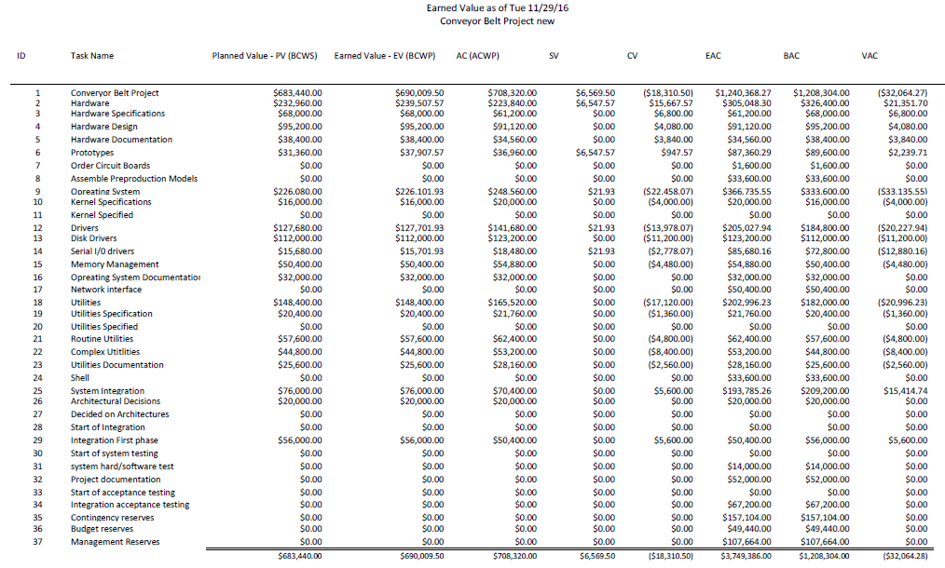

**Appendix V**

**Tracking Gantt Chart**

